OBEJMA DO RUR DIN 1593

zaokrąglonymi końcami do średnicy 115
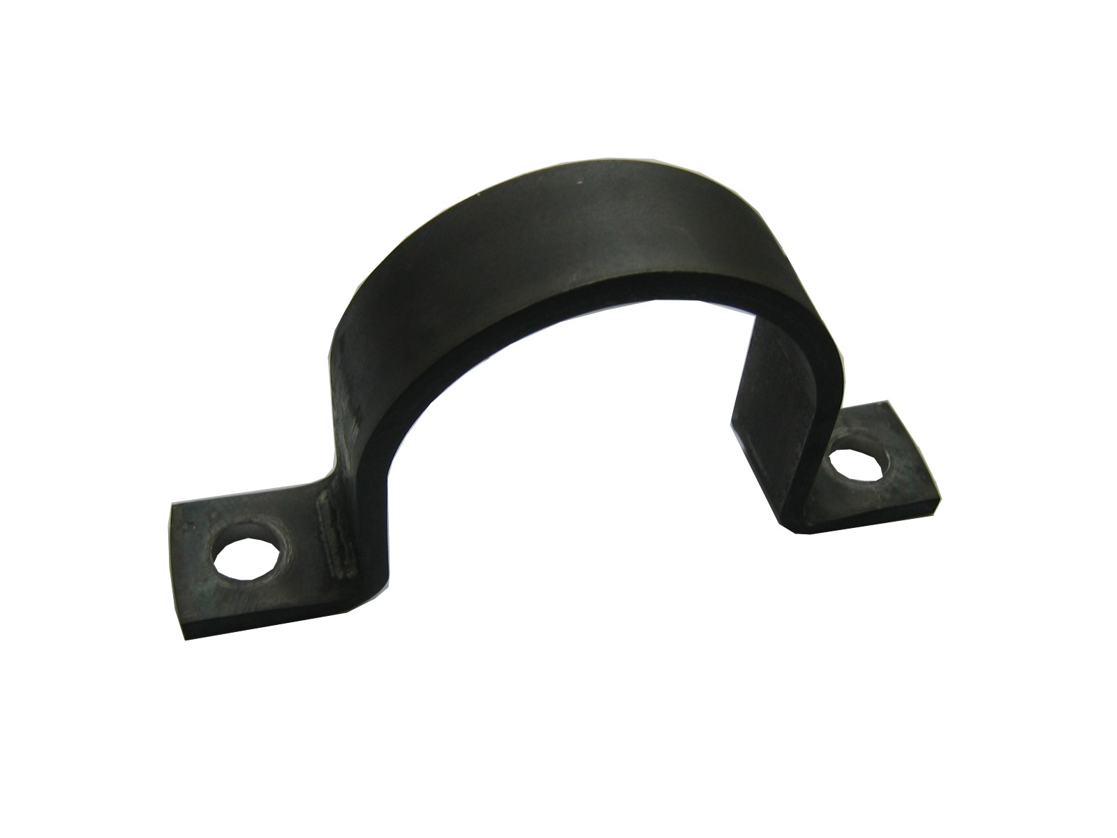

Oznaczenie  d1 | Zastosowanie do rur o średnicy | Wymiary
Oznaczenie  d1 | Zastosowanie do rur o średnicy | d2 | h | l1 | l2 | Bxs
7 | 5,5-7 | 6,6 | 5 | 44 | 28 | 16x2
9 | 7-9 | 6,6 | 6 | 48 | 32 | 20x
13 | 9,5-13 | 6,6 | 9 | 52 | 36 | 20x
15,5 | 13-15,5 | 6,6 | 12 | 56 | 40 | 20x
19 | 15,5-19 | 6,6 | 15 | 60 | 44 | 25x3
23 | 20-23 | 11 | 19 | 82 | 56 | 25x3
26 | 23-26 | 11 | 22 | 84 | 58 | 25x3
28,5 | 26-28,5 | 11 | 24 | 90 | 64 | 25x3
31 | 28,5-31 | 11 | 27 | 90 | 64 | 25x3
36 | 33-36 | 11 | 32 | 106 | 80 | 30x5
39 | 36-39 | 11 | 34 | 110 | 84 | 30x5
43 | 39-43 | 14 | 38 | 120 | 88 | 30x5
46 | 43-46 | 14 | 41 | 122 | 90 | 30x5
49 | 46-49 | 14 | 44 | 122 | 90 | 40x5
58 | 53-58 | 14 | 52 | 142 | 110 | 40x5
61 | 58-61 | 14 | 57 | 142 | 110 | 40x5
71 | 71-76 | 14 | 66 | 152 | 120 | 40x5
77 | 73-77 | 18 | 72 | 176 | 136 | 40x5
81 | 77-81 | 18 | 76 | 184 | 144 | 40x5
91 | 86-91 | 18 | 85 | 198 | 158 | 40x8
103 | 99-103 | 18 | 98 | 214 | 174 | 40x8
109 | 105-109 | 18 | 104 | 220 | 180 | 40x8
115 | 110-115 | 18 | 109 | 226 | 186 | 40x8

